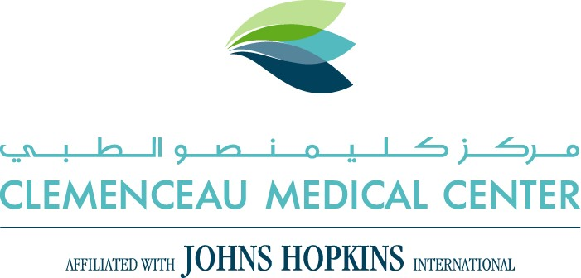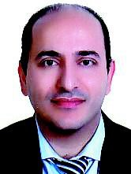

Abbas Khadra

MD, FRCSI, PHD, FEBU, FRCS Urol

**Urology and Andrology**

**Contact Information**

Phone number

:

00961

-

76966040

Email:

abbas.khadra@cmc.com.lb

**Medical Experience**

# *Education*

2011 – Fellowship in Andrology and Sexual Medicine – University College Hospital, London, UK.

2010 – Diploma in Andrology and Reconstructive Urology - University College Hospital, London, UK.

2009 – Fellow of European Board of Urology

2008 – Course in Brachytherapy – University Hospital Surrey, Guildford, UK.

2008 – Course in Genital Malignancy – University College Hospital, London, UK.

2007 – Course in Medical Management & Leadership – University of Sussex, UK.

2006 – Course in Female Urology – Institute of Urology, London, UK.

2006 – Course in Greenlight and HoLep – Institute of Urology, London, UK. 2005 – Docturate in Surgery (PHD) – University of London, London, UK.

2004 – Diploma in Ultrasound for Urologists – Portsmouth Uiniversity, UK.

2004 – Diploma in Urodynamics – Bristol Institute of Urology, Bristol, UK.

2001 – Diploma in Urology – Institute of Urology, London, UK.

2001 – Member of Royal College of General Practitioners - London, UK.

2000 – Diploma in Medical Education – St George’s Hospital Medical School, London, UK.

2000 – Fellow of Royal College of Surgeons in General Surgery – London, UK.

1997 – Course in Trauma life support – Royal college of Surgeons, London, UK. 1996 – Course in Cardiac Life support - Royal college of Surgeons, London, UK.

1995 – Diploma of Doctor of Medicine – University of Wales College of Medicine, Cardiff.

# *Training*

2010 – Training in andrological surgery including infertility and reconstructive surgery (Penile prosthesis and artificial sphincter) – University College Hospital, London, UK.

2010 – Completion of Urological training – London Deneary, London, UK.

2009 – Training in localized treatment for prostate cancer (Brachytherapy, HIFU and Cryotherapy) - Institute of Urology, London, UK.

2008 – Training in Laparoscopy and Robotics – Royal Surrey Hospital, UK.

2007 – Training in Endourology and percutaneous surgery – Stone centre, Frimley Park Hospital, Surrey, UK.

2007 – Training in Greenlight and Holmium laser surgery to the prostate - Institute of Urology, London, UK.

2007 – Training in Paediatric Urology - Institute of Urology, London, UK.

2006 – Training in Female Urology (Incontinence surgery and Vesico-vaginal fistula repairs) - Institute of Urology, London, UK.

**Languages –** English, Arabic, French.

# Memberships

* Lebanese order of Physicians.- General Medical Council, UK.
* European Urological Association.
* British Association of Urological Surgeons.
* Medical Protection Society.

# Awards and Research grants

1993 – Medical Research Council Elective Award - Roger Fund for Elective Study

1. – Roussel Medical Elective Prize
2. – Pysician in Wales Prize - Best Elective Research project

1993 – Zenecca (ICI) travel grant - Electives in Gambia

1993 – 3M Health Care Award - For Elective project in Gambia

2000 – Clair Wand Fund (BMA) - Research project on Testicular Cancer

1. – Cancer Prevention Research Trust - Research Project on Testicular Cancer
2. – Prostate Research Campaign UK - Research project on Prostatitis (PHD)

2005 – Best Poster for clinical research - British Prostate Group Conference 2005

2009 – Clinical excellence award for patient care - University of London Hospital **Publications and Presentation**

**Khadra A,** Alkabir J. MRCS Core Modules: Essential Revison Notes. PASTEST 1998

**Khadra A,** Oakshott P. General practice perspective on cancer services. Family Practice 2001; 18(4): 463-464.

**Khadra A,** Cappuccio F. Understanding health risks associated with ethnic groups- People of African origin. Pulse 2001; 61(35): 52-53.

**Khadra A,** Cappuccio F. Understanding health risks associated with ethnic groups- People of South Asian origins. Pulse 2001; 61(37): 60-61.

**Khadra A,** Oakshott P. Pilot study of Testicular Cancer awareness and Testicular selfexamination in men attending two South London general practices. Family Practice 2002; 19(3): 294-296.

**Khadra A,** Ogden J, Ambrose L. A questionnaire study of GP’s and Patients’ beliefs about different components of Patient centredness. Patient Education and Counselling 2002; 47: 223-227.

**Khadra A,** Corbett K. Enabling men to access help for testicular cancer. Men’s Health Journal 2002; 1(5): 154-155.

**Khadra A,** Hay P, Shattock R, Luzzi G. Interleukin – 8 levels in seminal plasma in Chronic prostatitis and Non-specific Urethritis. BJUI 2006; 97: 1043-1046.

**Khadra A,** Anderson B. Acute urinary retention: developing an A&E pathway. Bristish Journal of Nursing 2006; 15(8): 434-438.

**Khadra A,** Coker C, Lavelle M.Harpoon excision: A simple technique for excision of epididymal cysts. Current Urology 2007; 1:208-209.

**Khadra A,** Rane A. Magnetic anchoring and guidance system instrumentation for laparoendoscopic single-site surgery/natural orifice transluminal endoscopic surgery: lack of histologic damage after prolonged magnetic coupling across the abdominal wall. Journal of Endourology 2011; 25(2): 9-12.

**Khadra A,** Rane A. Renal damage caused by warm ischaemia during laparoscopic and robotassisted partial nephrectomy; An assessment using Tc-99m glomerular filtration rate. Journal of Endourology 2011; 25(2): 9-12.

**Khadra A,** Ismail M. Cryoshock following laparoscopic-assisted renal cryotherapy for renal cell carcinoma. A case report and review of literatures. Current Urology 2011; 5:1159-1160.

**Khadra A.** Case presentation – bladder SCC after long term suprapubic catheterization. Current Urology 2011;5:1148-1149. **Khadra A,** Ralph D, Minhas S, Garaffa G.The outcome of penile prosthetic revision surgery. European Urology. In Press.