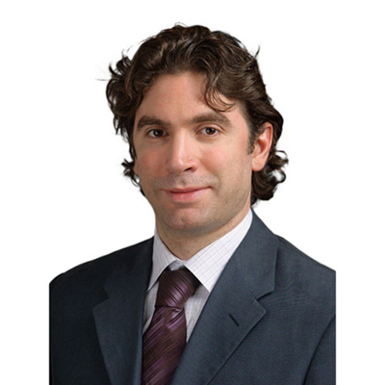

**Dr. Adel B. Tabchy, M.D., M.S.**

**Specialty:**

Hematology-Oncology

**Sub-Specialty / Area of Expertise:**

Breast cancer

Women cancers

Ovarian cancer

Uterine cancer

Endometrial cancer

Cervical cancer

**Summary Statement:**

Dr. Tabchy is a Professor of Medicine and Consultant Medical Oncologist who subspecializes in Breast and Women cancers. He trained at the renowned M.D. Anderson Cancer Center in Houston, USA. He obtained a graduate degree from the Massachusetts Institute of Technology, then pursued residency training at Boston University, then Medical Oncology Fellowship and also subspecialty training in Breast and Women cancers from the M.D. Anderson Cancer Center in Houston, Texas, where he then served as Faculty and worked at the Institute for Personalized Cancer Therapy. He is double American Board certified in Medical Oncology and Internal Medicine.

Dr Tabchy was then recruited to a large cancer and imaging consortium in Los Angeles where he served as U.S. Medical Director for Research and cared for breast cancer patients at the cancer centers in Los Angeles. Following this, he was recruited back to academia as a Consultant in Breast Medical Oncology and Professor of Medicine at the Washington University School of Medicine in St. Louis, where he focused on patient care, translational research, and teaching. There he was the recipient of prestigious research grants from the National Institutes of Health. His research focuses on leveraging genomic technologies for the molecular analyses of tumors, the design of biomarker-driven translational trials, and integrating molecular diagnostics with molecular imaging to help enable Precision Medicine.

Dr. Tabchy has published numerous research articles in first tier medical journals, and regularly presents his work at national and international cancer conferences. He is known and well respected in the world of Breast cancer in the USA, Europe and the Middle East.

**Qualifications:**

Doctor or Medicine, M.D., M.S.

Professor of Medicine

American Board of Medical Oncology

American Board of Internal Medicine

**Academic and Professional Societies:**

Member of the American Society of Clinical Oncology (ASCO).

Member of the American Association for Cancer Research (AACR).

Member of the American Academy for the Advancement of Science (AAAS).

Member of the Massachusetts Medical Society (MMS).

Member of the American College of Physicians (ACP).

Member of the American Medical Association (AMA).

**Languages:**

English, French, Arabic

**Contact:**

Practices at Clemenceau Medical Center Beirut, Comprehensive Cancer Centre, Beirut, Lebanon.

Consultant in Medical Oncology and Hematology.

Department of Medical Oncology.

+961-70-128 563